Project Design Phase-II
Data Flow Diagram & User Stories

Date | 18 June 2026
Team ID
Project Name | ShopEZ – MERN Stack E-Commerce Platform
Maximum Marks | 4 Marks

Data Flow Diagrams:
A Data Flow Diagram (DFD) shows how data enters and leaves the system, what transforms it, and where it is stored. The level-0 (context) view for ShopEZ is described below.

Level 0 – Context Diagram
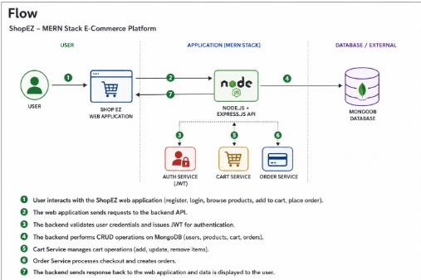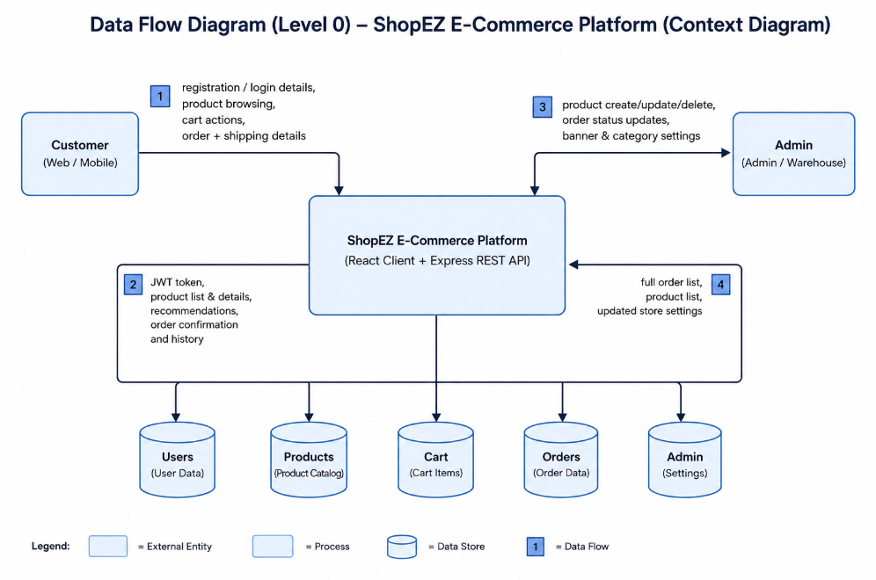
User Stories
Use the below template to list all the user stories for the product.
User Type | Functional Requirement (Epic) | Story No. | User Story / Task | Acceptance Criteria | Priority | Release
Customer | Registration | USN-1 | Register with username, email and password. | Account is created, password is hashed, JWT is returned. | High | Sprint-1
Customer | Login | USN-2 | Log in with email and password. | Valid credentials return a JWT and user profile. | High | Sprint-1
Customer | Catalogue | USN-3 | Browse products and open a detail page. | All products list; detail page shows name, price, description, image. | High | Sprint-1
Customer | Cart | USN-4 | Add / remove products and adjust quantity. | Cart reflects correct items and quantities per user. | High | Sprint-2
Customer | Checkout | USN-5 | Enter shipping address and place an order. | Order is created, cart is cleared, confirmation shown. | High | Sprint-2
Customer | Orders | USN-6 | View order history and status. | Past orders list with status, newest first. | Medium | Sprint-2
Customer | Recommendations | USN-7 | See recommended products. | Suggestions based on previously ordered categories. | Medium | Sprint-3
Administrator | Manage Products | USN-8 | Add, edit and delete products. | Product changes persist and appear in the catalogue. | High | Sprint-3
Administrator | Manage Orders | USN-9 | View all orders and update status. | Order status updates (Pending / Shipped / Delivered). | High | Sprint-4
Administrator | Store Settings | USN-10 | Update banner and categories. | Banner and category list are saved and applied. | Low | Sprint-4

